**Dashboard Design**

|  |  |
| --- | --- |
| Date | 01 October 2025 |
| Team ID | SWUID20250181698 |
| Project Name | Global Inflation Dynamics (1980-2024): A Comparative Time-Series Analysis |
| Maximum Marks | 5 Marks |

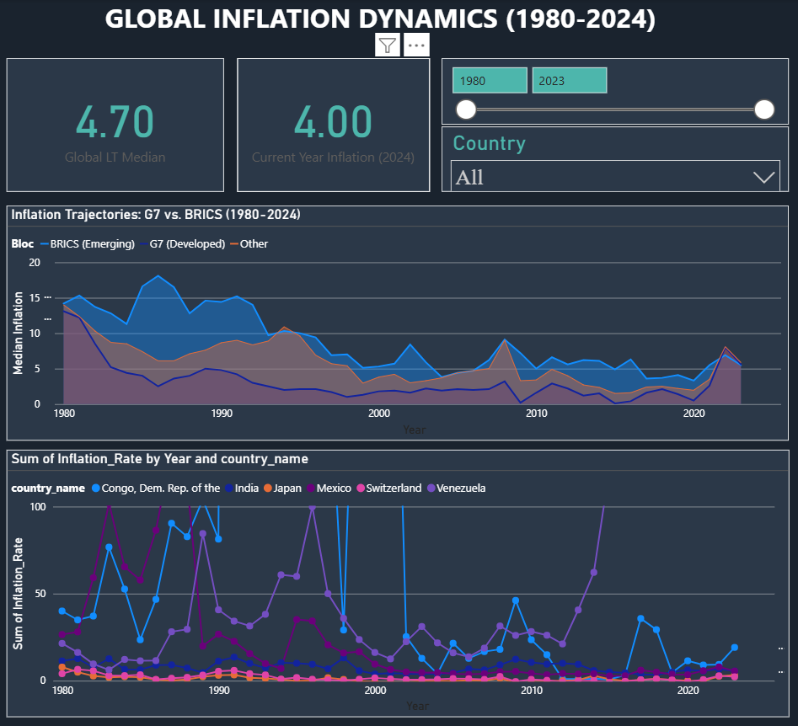

**Dashboard Design Principles**

|  |  |
| --- | --- |
| **Principle** | **Implementation in Inflation Dashboard** |
| **Clear and Intuitive Layout** | Utilizes a 3-panel grid layout: KPIs and Filters (Top Right), Core Comparative Trend (Center), and Detailed Outlier Analysis (Bottom). This guides the user's eye from summary to detail. |
| **Use Appropriate Visualizations** | Employs Line Charts for all time-series data to emphasize trends over time (G7/BRICS). Uses Card Visuals for Key Performance Indicators (KPIs) like the Global Median. |
| **Color and Theming** | Uses Contrasting Colors to differentiate blocs: Blue/Cool tones for stable/developed G7 economies and Red/Warm tones for volatile/emerging BRICS economies. |
| **Interactive Filters and Slicers** | Slicers are implemented for Year (as a slider) and Country Name (as a searchable list) to allow analysts to perform custom time-range and country-specific drill-downs. |
| **Measure Robustness** | All aggregation visuals use the Median Inflation DAX measure, ensuring the results are robust and not skewed by extreme hyperinflation outliers (e.g., Venezuela). |

**Dashboard Layout & Components**

|  |  |  |  |
| --- | --- | --- | --- |
| **Component Type** | **Title / Metric** | **Purpose / Description** | **Data Source / Visual Used** |
| **KPI Card 1** | **Global Long-Term Median Inflation (1980-2024)** | Shows the single benchmark for global price stability over the 45-year period. | Card Visual / DAX Measure |
| **KPI Card 2** | **Current Year Median Inflation (2024 Forecast)** | Provides the most immediate, actionable forecast metric for global risk assessment. | **Card Visual** / DAX Measure |
| **Control Panel** | **Year Slicer (Slider) & Country Name Slicer** | Allows for custom time-range analysis (e.g., focus on post-2015) and specific country highlighting. | Slicer Visuals |
| **Main Chart (Center)** | **G7 vs. BRICS Median Inflation Trajectories** | The primary comparative visual that answers the core business question on economic bloc differences and synchronicity. | Line Chart (X=Year, Y=Median Inflation, Legend=Bloc) |
| **Secondary Chart (Bottom)** | **Extreme Inflation Outliers** | Highlights the range of volatility by plotting the highest (e.g., Venezuela) and lowest (e.g., Japan) inflation countries. | Line Chart (Filtered for extremes, Y-Axis capped for visibility) |

**Major Outcomes and Insights**

The finished dashboard provides the following bullet-point outcomes:

* **Confirmed Stability Gap:** The dashboard clearly shows that G7 economies maintained a long-term median inflation rate significantly lower and less volatile than the BRICS bloc, confirming the stability risk differential.
* **Synchronous Shock**: The analysis highlights a sharp, simultaneous inflation spike in both G7 and BRICS after 2020, confirming the global nature of recent supply chain and geopolitical shocks.
* **Robust Metrics**: By relying on the Median measure, the dashboard successfully mitigates the distorting effect of hyperinflation in outlier countries (like Venezuela) on global averages, ensuring data integrity.
* **Targeted Intervention:** Policy makers can use the slicers to prove if a current spike is unique to their nation or is part of the larger G7/BRICS bloc trend, guiding the choice between local or global policy responses.